**Exercise 1**

Score for completing the loop: 30.0/30.0

Score for average distance: 30.0/30.0

Score for maximum distance: 30.0/30.0

Your time is 80.44800000000001

Your total score is: 100.0/100.0

total steps: 80448

maxMinDist: 4.34250914661494

avgMinDist: 0.6088963662034619

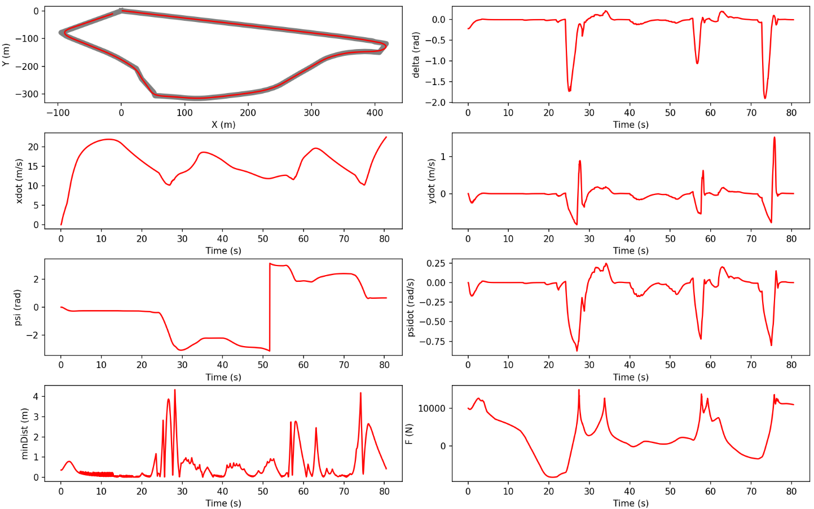

**Exercise 2**

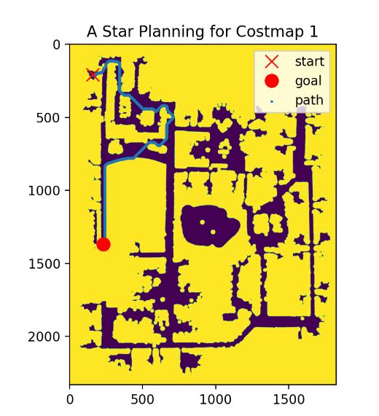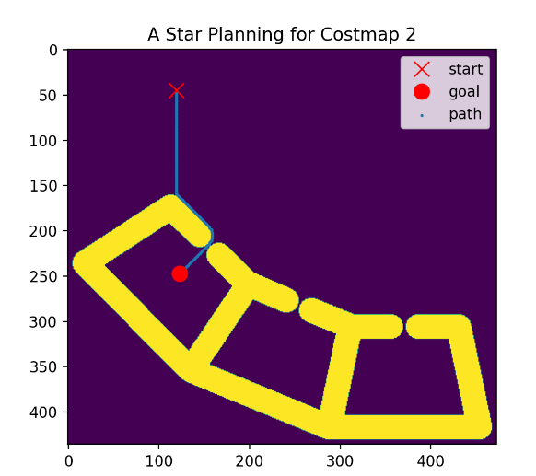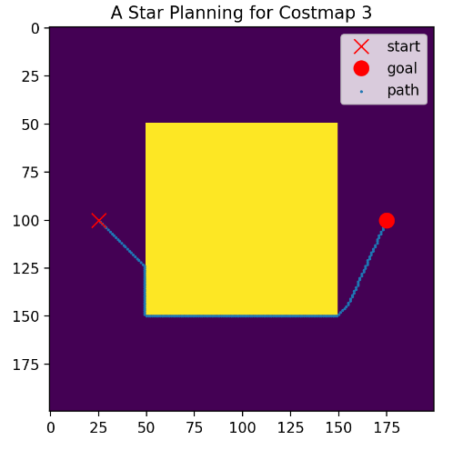

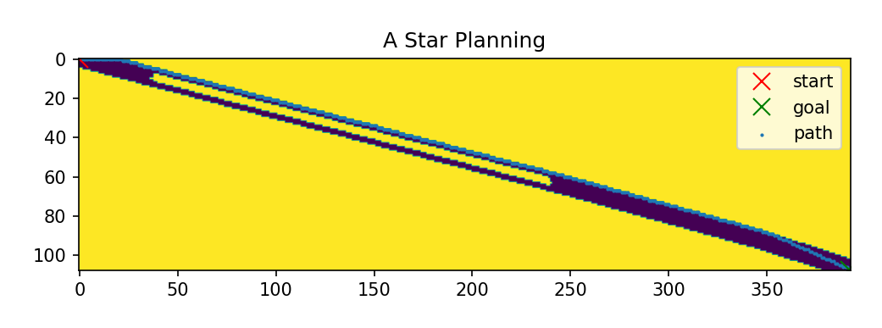

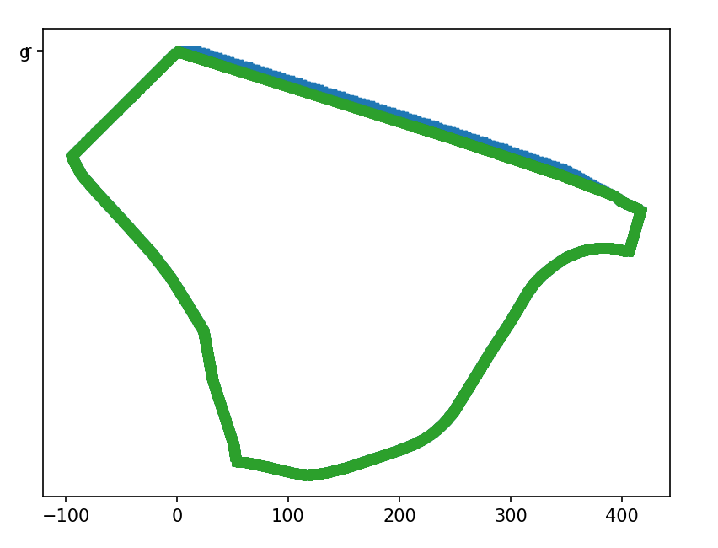

**Finish time: 98s**

reach goal

path length 393

total steps: 98144

maxMinDist: 6.856665312238587

avgMinDist: 1.9069897999180225

